**Database Management System**

**Lab Assignment - 4**

Name: Ashutosh Soni

Id: 2018ucp1505

Q1: WAQ to create a table: bookstore (bookid, year, month, volume, author, price).

Ans:

**Query for the problem:**

CREATE TABLE bookstore(

bookid int,

year varchar(4),

month int(2),

volume int,

author varchar(20),

price int

);

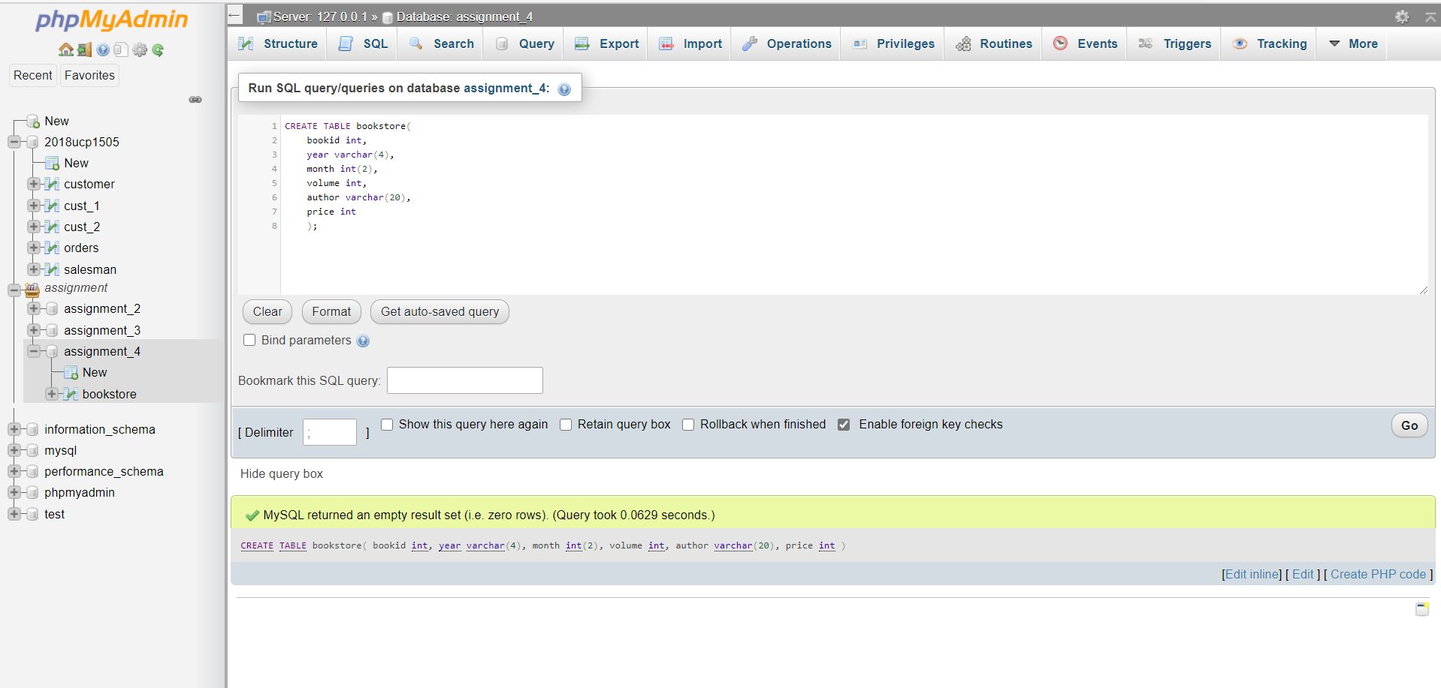**Screenshot of the Query:**

Q2:  WAQ to add "NOT NULL" constraint to "price" and "primary key" constraint to "bookid".

Ans:

**Query for the Problem:**

ALTER TABLE bookstore

MODIFY price int NOT NULL;

ALTER TABLE bookstore

MODIFY bookid int PRIMARY KEY;

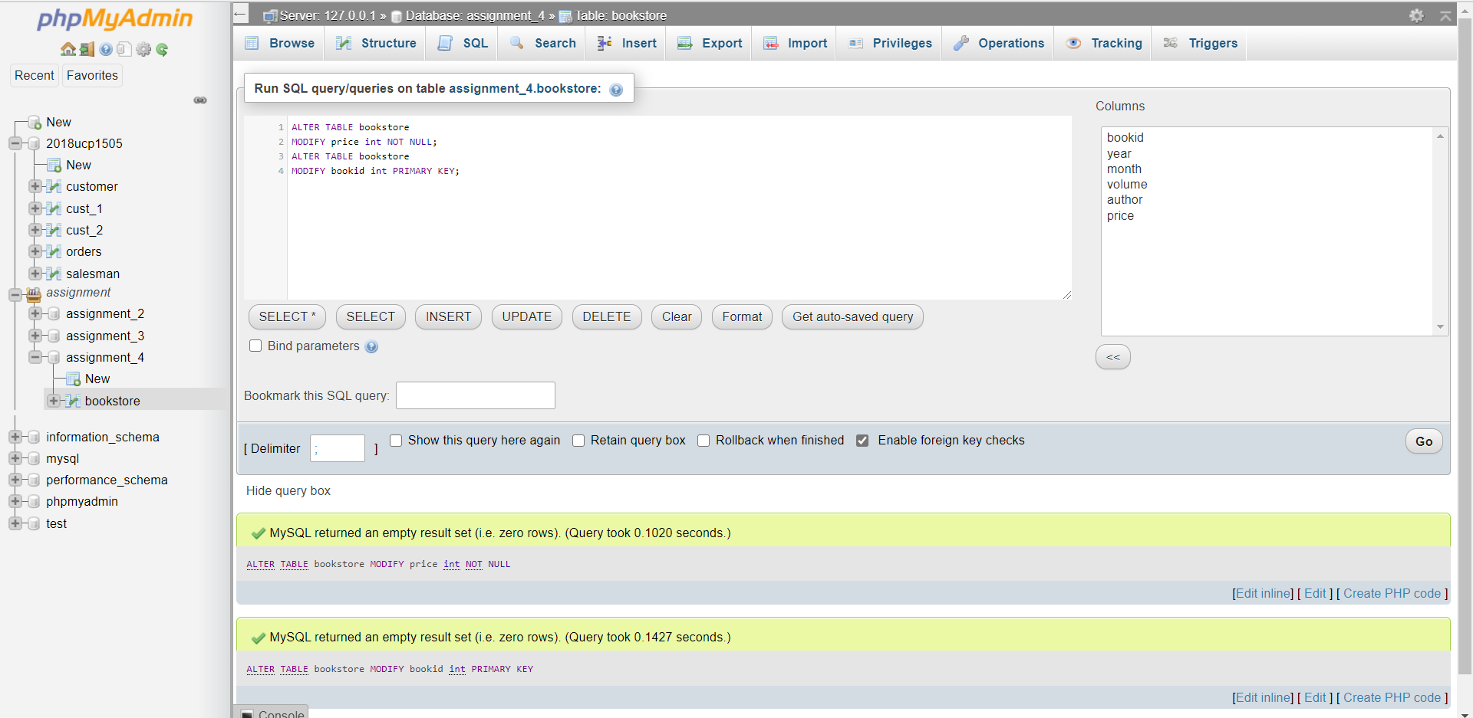**Screenshot of the Query:**

Q3: WAQ to insert 10 records in the above table using a single query.

Ans:

**Query for the Problem:**

INSERT INTO `bookstore`(`bookid`, `year`, `month`, `volume`, `author`, `price`)

VALUES

(1, '2002', 5,100, 'Andrew Deshuza',250),

(2, '2001', 2,250, 'Mona Rani',550),

(3, '1999', 4,550, 'Grew Rani',100),

(4, '1980', 1,440, 'Manirach Rach',600),

(5, '2005', 8,400, 'Monalisha Rani',200),

(6, '2019', 9,399, 'Stepthen Robart',500),

(7, '2010', 10,400, 'Andrew Russel',600),

(8, '1999', 12,320, 'Sachin Dhawan',100),

(9, '1998', 11,220, 'Bhem Kohli',240),

(10, '2000',12,320, 'Ramesh chacha',200);

**Screenshot of the Query:**

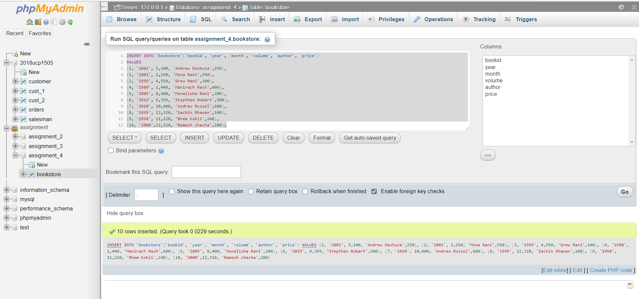

**Database after Executing Query:**

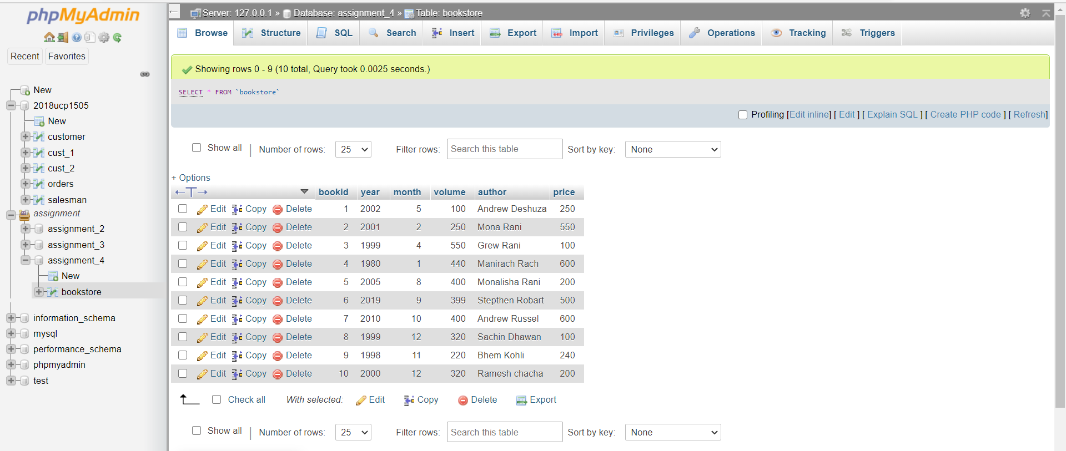

Q4:  WAQ to delete top 2 records from the table.

Ans:

**Query for the Problem:**

DELETE FROM ‘bookstore’ LIMIT 2;

**Screenshot of the Query:**

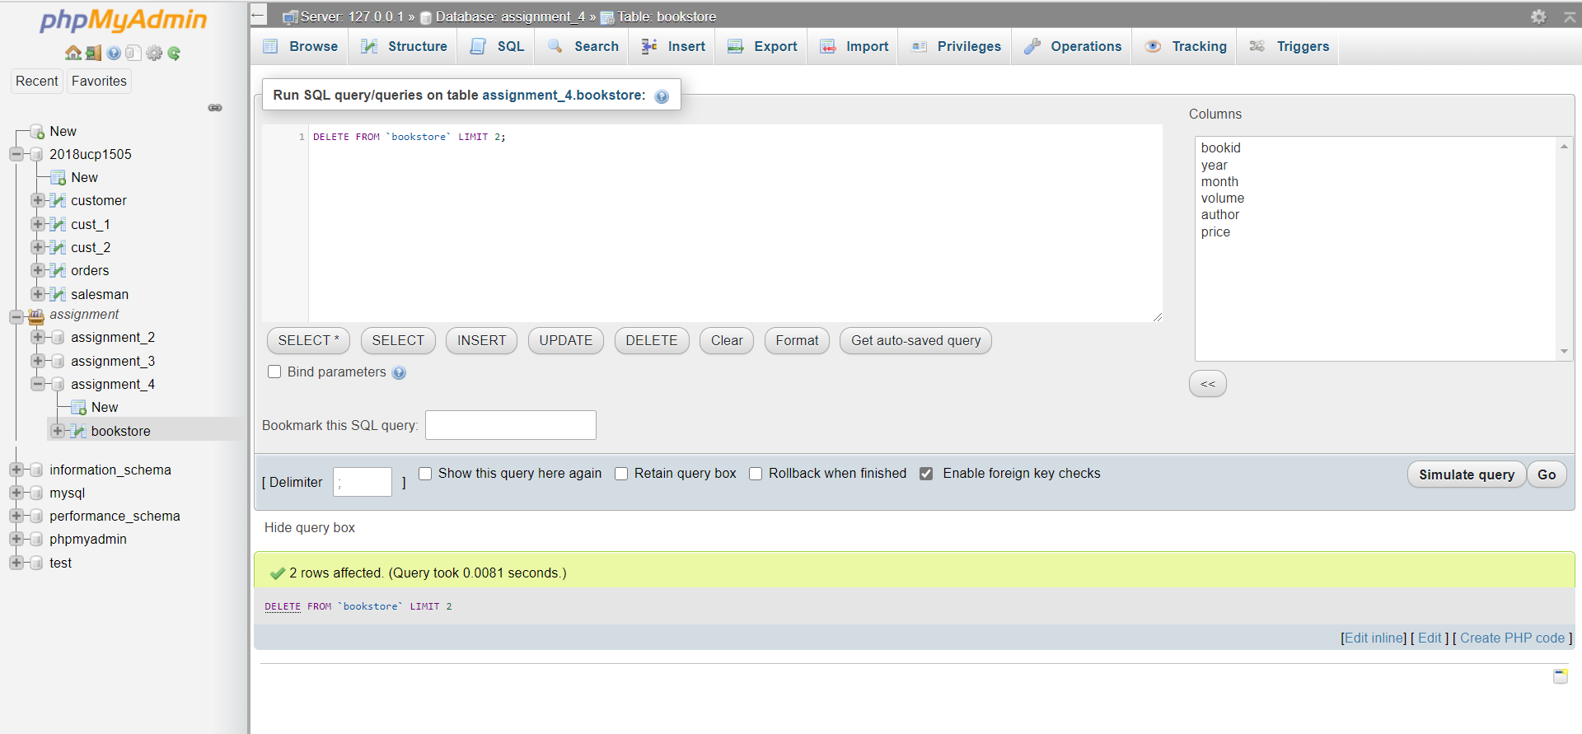

**Database after Executing Query:**

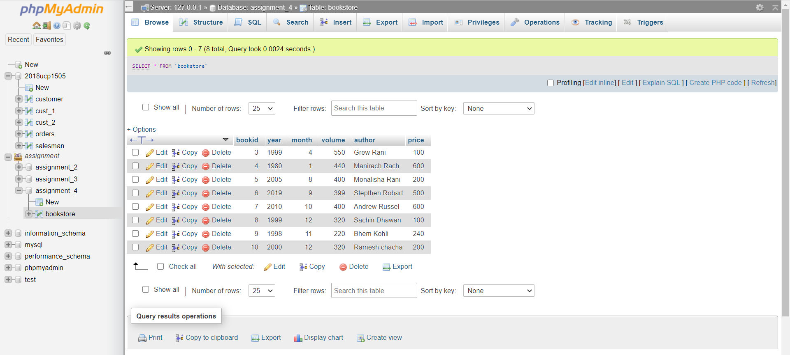

Q5:  WAQ to change the "year" for books written by "Danish Kumar" to "2020".

Ans:

**Query for the Problem:**

UPDATE ‘bookstore’

SET year=’2020’

WHERE author = ‘Danish Kumar’ ;

**Screenshot of the Query:**

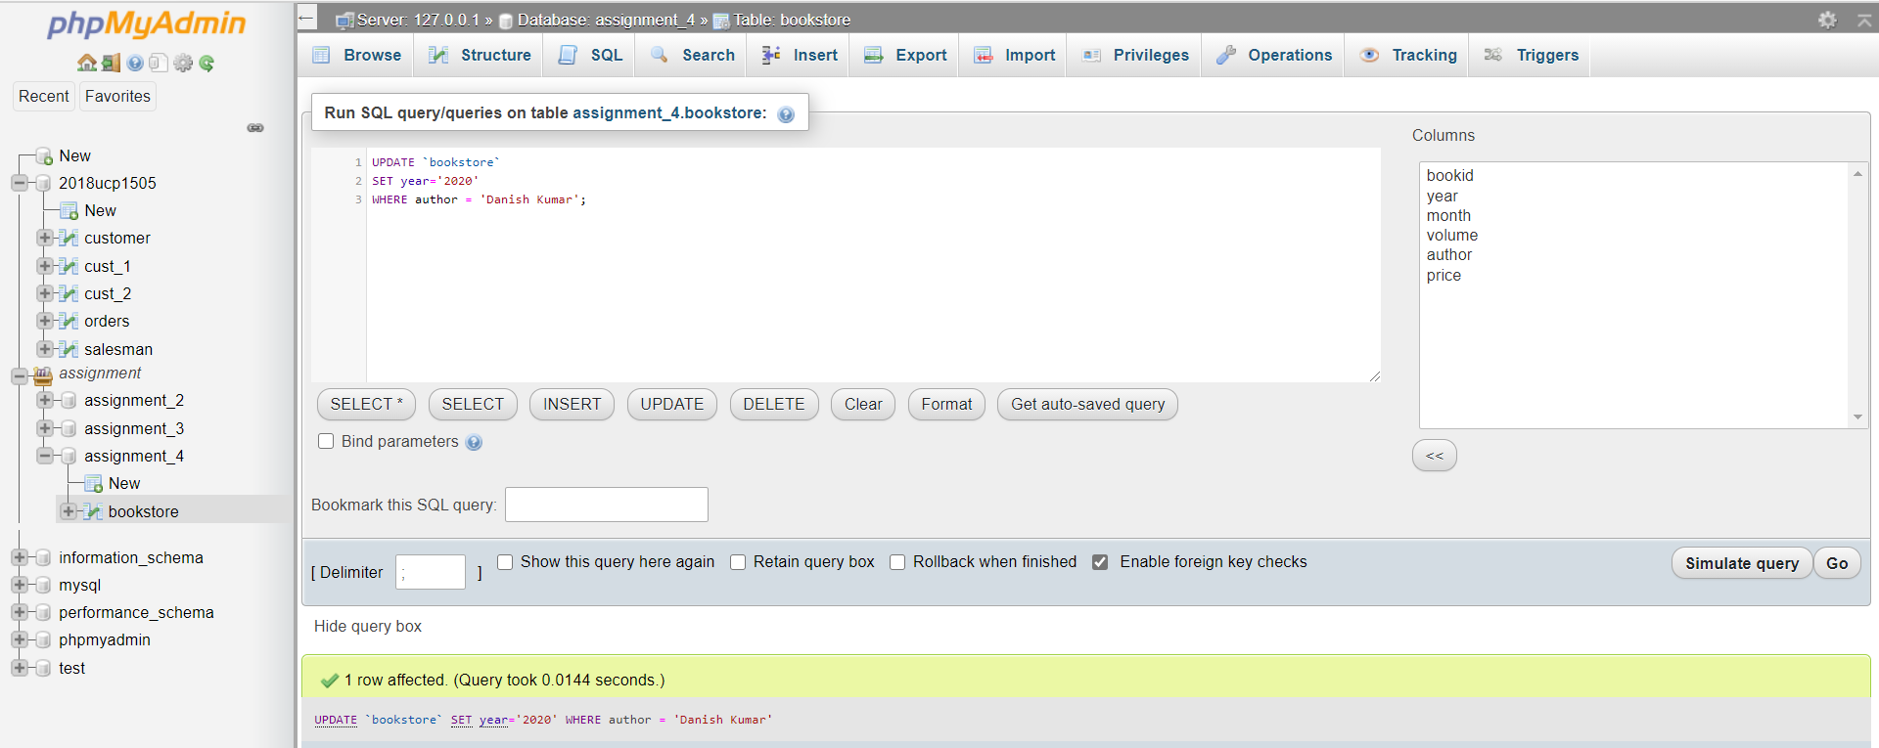

**Database after Executing Query:**



Q6:  WAQ to change the data type of "price" column from  "INT" to "FLOAT"

Ans:

**Query for the Problem:**

ALTER TABLE bookstore

MODIFY price float;

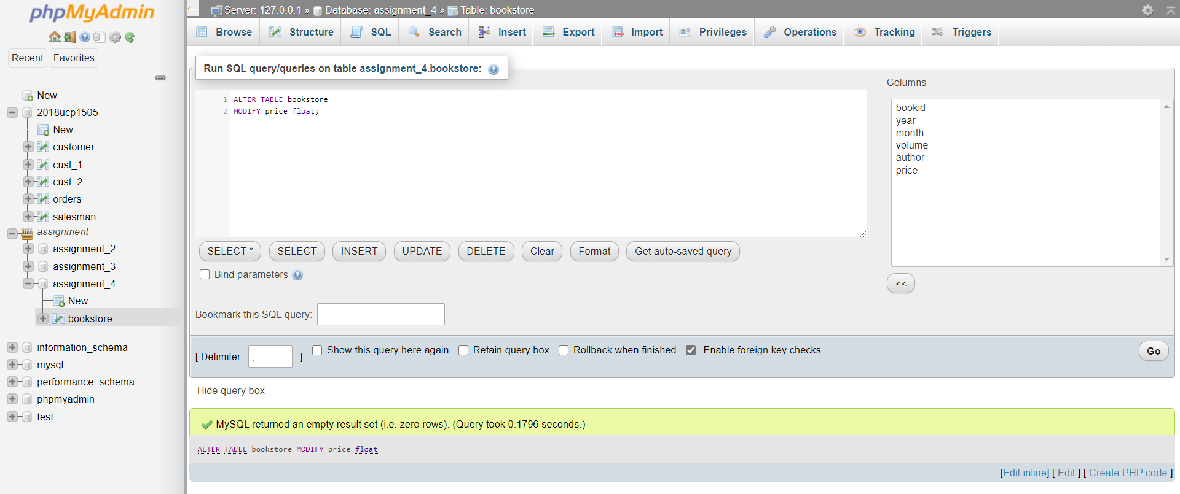**Screenshot of the Query:**

**Database after Executing Query:**



Q7:  WAQ to add a new column "publisher" to the table (this new column must have NOT NULL constraint).

Ans:

**Query for the Problem:**

ALTER TABLE bookstore

ADD publisher varchar(20) NOT NULL;

**Screenshot of the Query:**

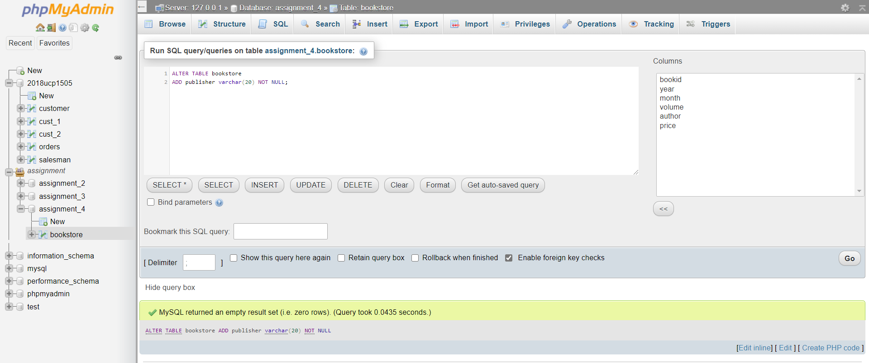

**Database after Executing Query:**

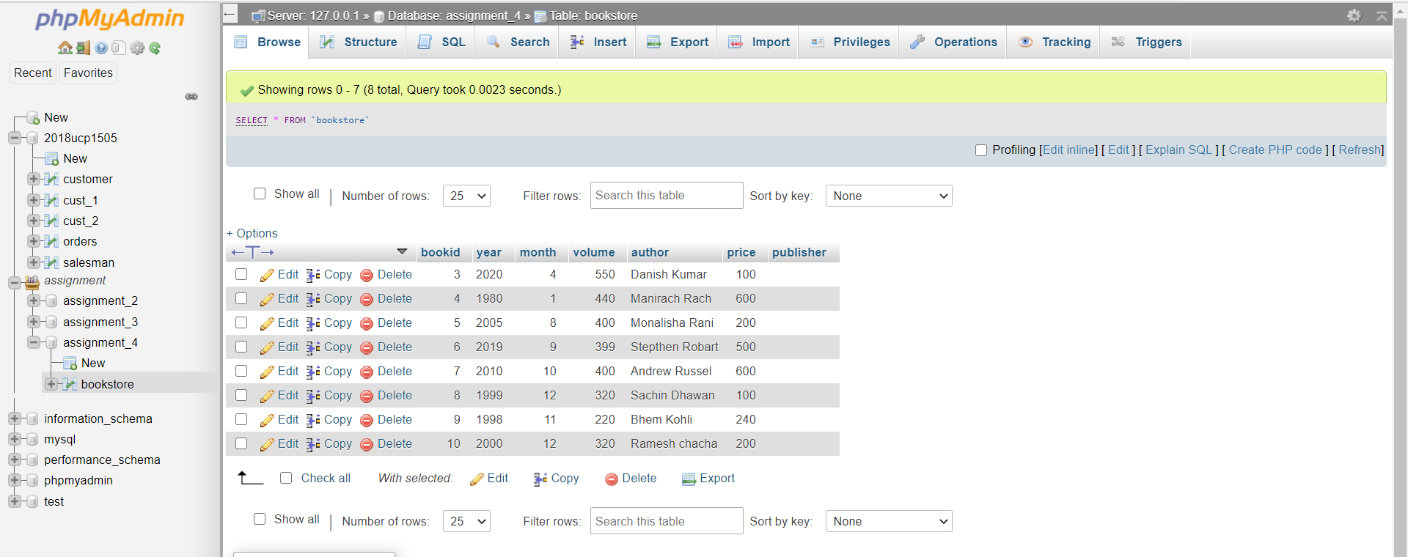

Q8: WAQ to calculate the total number of books sold each month. Order your results chronologically.

Ans:

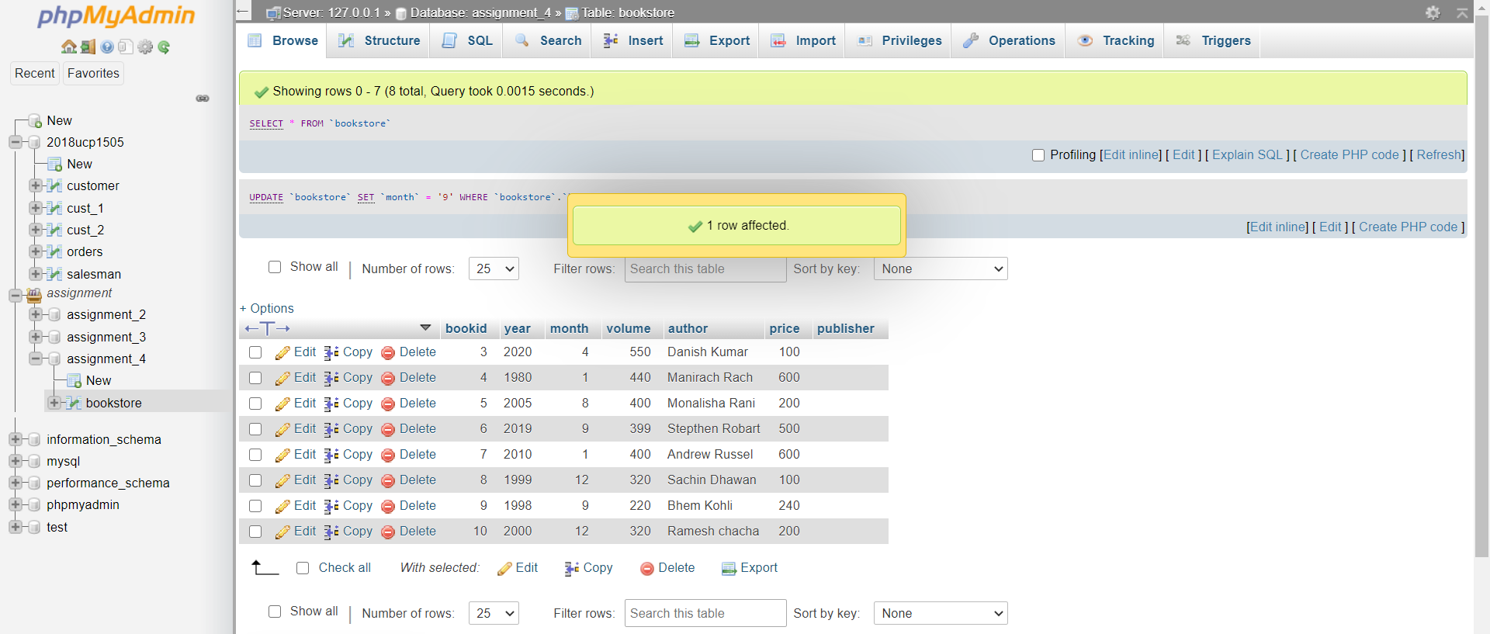**Database before Query:**

**Query for the Problem:**

SELECT month, COUNT(bookid) as total

FROM bookstore

GROUP by month

ORDER by month

**Screenshot of the Query:**

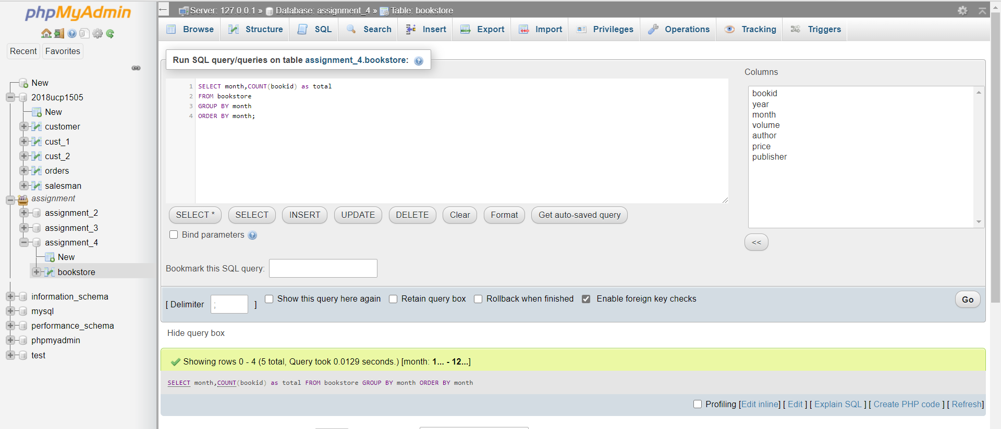

**Database after Executing Query:**

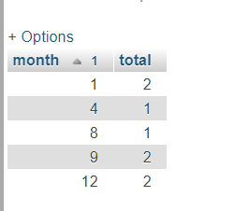

Q9:  Create index using columns "year" and "month" on the table and name the index as "idx_ym"

Ans:

**Query for the Problem:**

CREATE INDEX idx_ym

ON bookstore (year,month);

**Screenshot of the Query:**

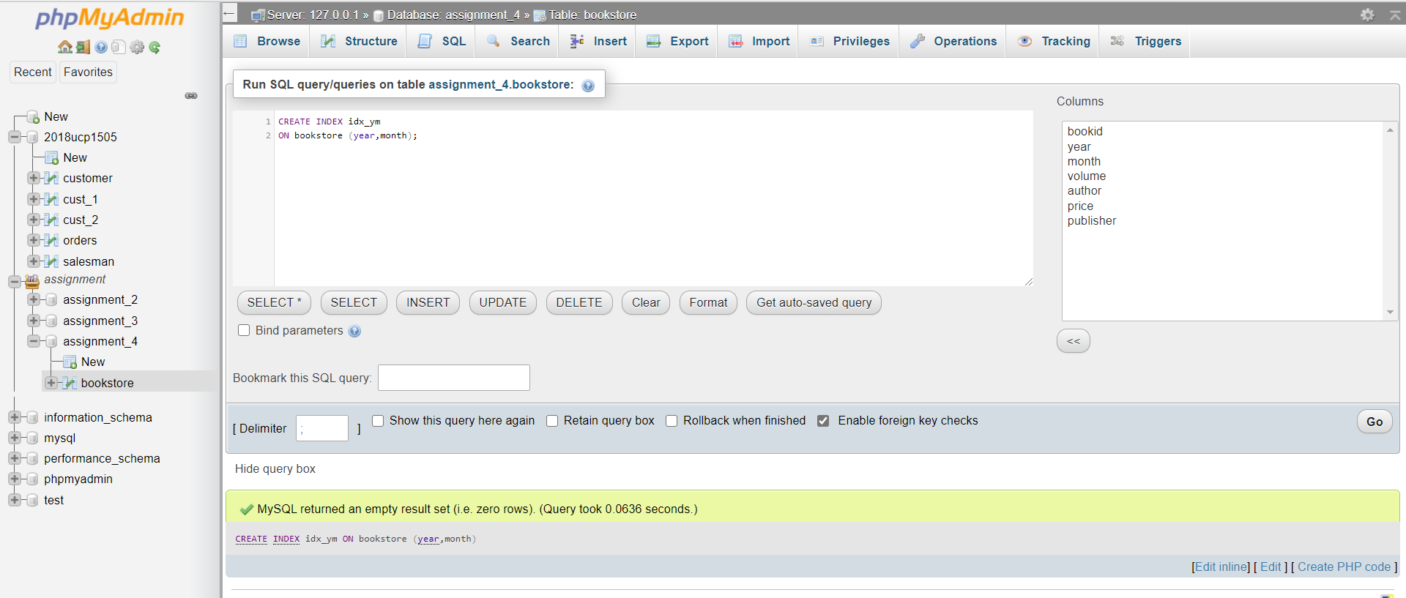

Q10:  WAQ to truncate all records from the table.

Ans:

**Query for the Problem:**

TRUNCATE TABLE bookstore;

**Database after Executing Query:**

